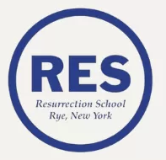

**Incoming 5th Grade Summer Reading List**

Cricket in Times Square - George Seldon

**Required Summer Reading**

**Please choose 1 additional book from the list below:**

Allies - Alan Gratz

Tuck Everlasting - Natalie Babbitt

Shiloh - Phillis Naylor Reynolds

Hatchet - Gary Paulsen